**LABS CONFIGURATION**

COURSE-CODE: CT-376

COURSE-TITLE: COMPUTER COMMUNICATION NETWORKS

SUBMITTED BY:   
FATIMA SHEHZAD

CT-20036

SECTION A

CSIT BATCH 2020

SUBMITTED TO:

SIR AHMED ZAKI

Lab 2

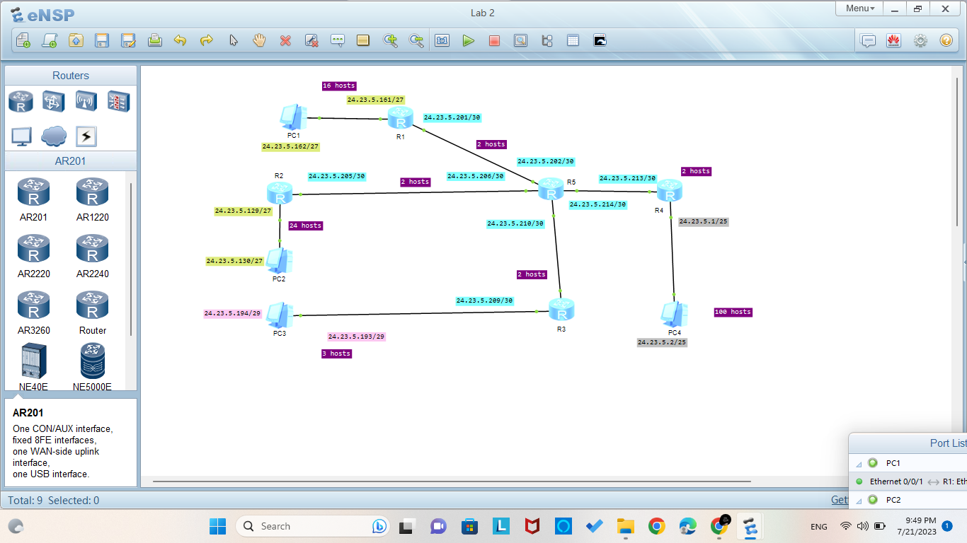

Lab 3

Configuration is not done in lab 3 because it is not required . Only IPs are assigned as mentioned in diagram.

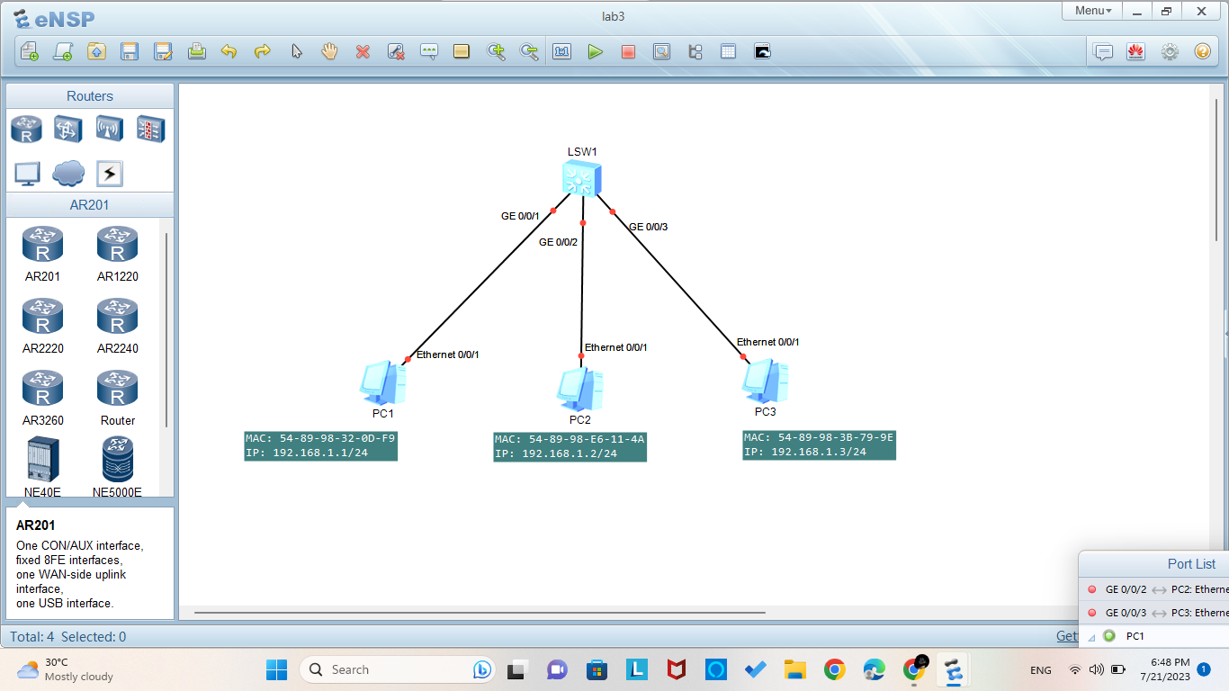

Lab 4

LSW1:

interface GigabitEthernet0/0/1

port link-type access

port default vlan 10

#

interface GigabitEthernet0/0/2

port link-type access

port default vlan 10

#

interface GigabitEthernet0/0/3

port link-type trunk

port trunk allow-pass vlan 20 30

#

interface GigabitEthernet0/0/4

port link-type trunk

port trunk allow-pass vlan 10 20 30

#

interface GigabitEthernet0/0/8

port link-type access

port default vlan 30

#

LSW2:

interface GigabitEthernet0/0/1

port link-type trunk

port trunk allow-pass vlan 10 30

#

interface GigabitEthernet0/0/2

port link-type trunk

port trunk allow-pass vlan 10 20 30

#

interface GigabitEthernet0/0/3

port link-type access

port default vlan 20

#

interface GigabitEthernet0/0/4

port link-type access

port default vlan 20

#

interface GigabitEthernet0/0/9

port link-type access

port default vlan 30

#

LSW3:

interface GigabitEthernet0/0/1

port link-type trunk

port trunk allow-pass vlan 10 30

#

interface GigabitEthernet0/0/3

port link-type trunk

port trunk allow-pass vlan 20 30

#

interface GigabitEthernet0/0/5

port link-type access

port default vlan 10

#

interface GigabitEthernet0/0/6

port link-type access

port default vlan 30

#

interface GigabitEthernet0/0/7

port link-type access

port default vlan 20

#

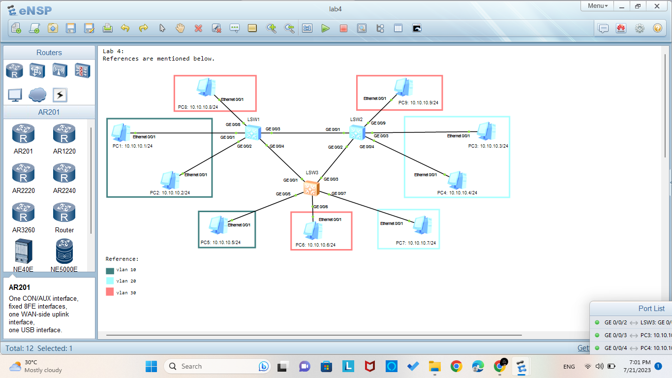

Lab 4 from Lab Manual

LSW1:

interface GigabitEthernet0/0/1

port link-type access

port default vlan 20

#

interface GigabitEthernet0/0/2

port link-type access

port default vlan 20

#

interface GigabitEthernet0/0/3

port link-type access

port default vlan 10

#

interface GigabitEthernet0/0/4

port link-type access

port default vlan 10

#

interface GigabitEthernet0/0/10

port link-type trunk

port trunk allow-pass vlan 10 20

#

LSW2:

interface GigabitEthernet0/0/1

port link-type trunk

port trunk allow-pass vlan 10 20

#

interface GigabitEthernet0/0/5

port link-type access

port default vlan 10

#

interface GigabitEthernet0/0/6

port link-type access

port default vlan 20

#

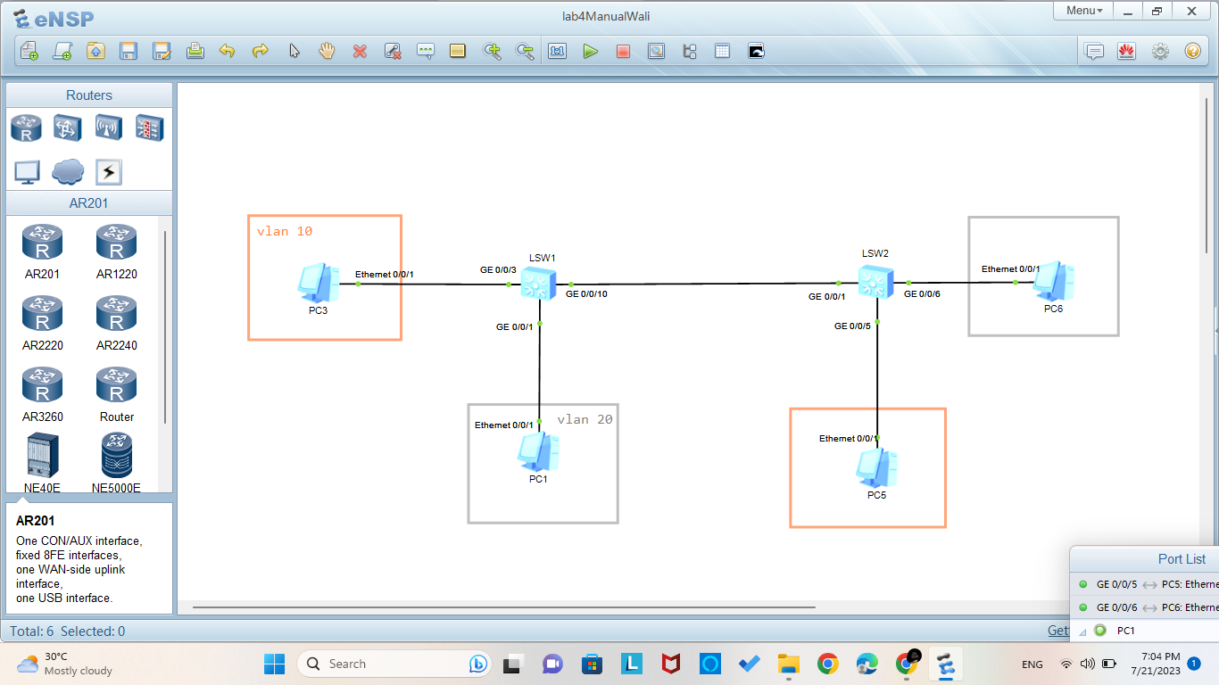

Lab 5

LSW1:  
interface GigabitEthernet0/0/1

port link-type access

port default vlan 10

#

interface GigabitEthernet0/0/2

port link-type access

port default vlan 10

#

interface GigabitEthernet0/0/3

port link-type access

port default vlan 20

#

interface GigabitEthernet0/0/4

port link-type access

port default vlan 20

#

interface GigabitEthernet0/0/5

port link-type trunk

port trunk allow-pass vlan 10 20

#

interface GigabitEthernet0/0/6

port link-type trunk

port trunk allow-pass vlan 10 20

#

R1:

interface Ethernet0/0/0

ip address 192.168.10.150 255.255.255.0

#

interface Ethernet0/0/1

ip address 192.168.20.150 255.255.255.0

#

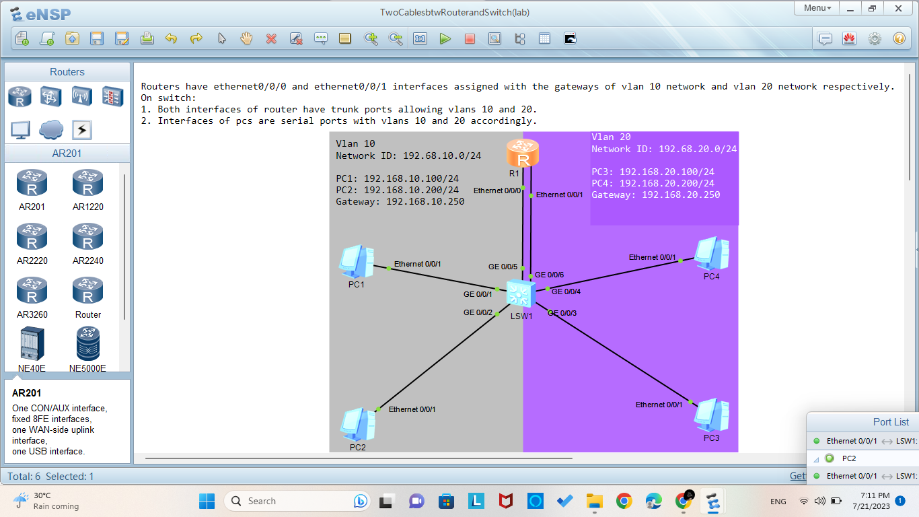

Lab 6

LSW2:

interface GigabitEthernet0/0/1

port link-type access

port default vlan 10

#

interface GigabitEthernet0/0/2

port link-type access

port default vlan 20

#

interface GigabitEthernet0/0/3

port link-type trunk

port trunk allow-pass vlan 10 20

#

R1:

interface Ethernet0/0/0.1

dot1q termination vid 10

ip address 10.10.10.250 255.255.255.0

#

interface Ethernet0/0/0.2

dot1q termination vid 20

ip address 20.20.20.250 255.255.255.0

#

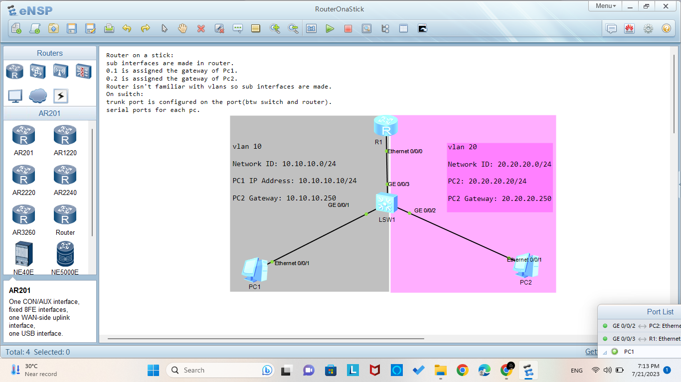

Lab 7

LSW1:

interface Vlanif10

ip address 10.10.10.250 255.255.255.0

#

interface Vlanif20

ip address 20.20.20.250 255.255.255.0

#

interface MEth0/0/1

#

interface GigabitEthernet0/0/1

port link-type access

port default vlan 10

#

interface GigabitEthernet0/0/2

port link-type access

port default vlan 10

#

interface GigabitEthernet0/0/3

port link-type access

port default vlan 20

#

interface GigabitEthernet0/0/4

port link-type access

port default vlan 20

#

interface GigabitEthernet0/0/10

port link-type trunk

port trunk allow-pass vlan 10 20

#

LSW2:

interface Vlanif10

ip address 10.10.10.250 255.255.255.0

#

interface Vlanif20

ip address 20.20.20.250 255.255.255.0

#

interface GigabitEthernet0/0/5

port link-type access

port default vlan 10

#

interface GigabitEthernet0/0/6

port link-type access

port default vlan 20

#

interface GigabitEthernet0/0/10

port link-type trunk

port trunk allow-pass vlan 10 20

#

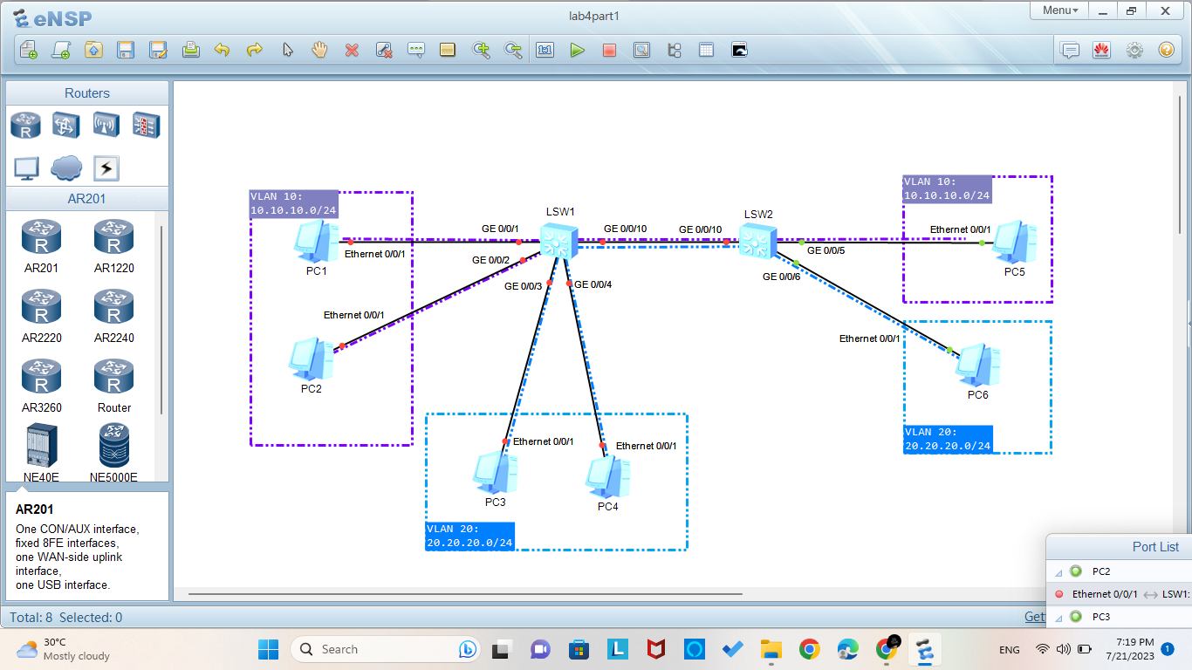

Lab 8

R1:

interface GigabitEthernet0/0/1

ip address 10.10.10.10 255.255.255.0

#

interface GigabitEthernet0/0/2

#

interface GigabitEthernet0/0/3

ip address 100.100.100.100 255.255.255.0

#

ip route-static 172.16.19.0 255.255.255.0 10.10.10.20

ip route-static 192.168.10.0 255.255.255.0 100.100.100.200

#

R2:

interface GigabitEthernet0/0/1

ip address 10.10.10.20 255.255.255.0

#

interface GigabitEthernet0/0/2

ip address 172.16.19.10 255.255.255.0

#

ip route-static 100.100.100.0 255.255.255.0 10.10.10.10

ip route-static 192.168.10.0 255.255.255.0 172.16.19.20

#

R3:

interface GigabitEthernet0/0/1

ip address 192.168.10.20 255.255.255.0

#

interface GigabitEthernet0/0/3

ip address 100.100.100.200 255.255.255.0

#

ip route-static 10.10.10.0 255.255.255.0 100.100.100.100

ip route-static 172.16.19.0 255.255.255.0 192.168.10.10

#

R4:

interface GigabitEthernet0/0/1

ip address 192.168.10.10 255.255.255.0

#

interface GigabitEthernet0/0/2

ip address 172.16.19.20 255.255.255.0

#

ip route-static 10.10.10.0 255.255.255.0 172.16.19.10

ip route-static 100.100.100.0 255.255.255.0 192.168.10.20

#

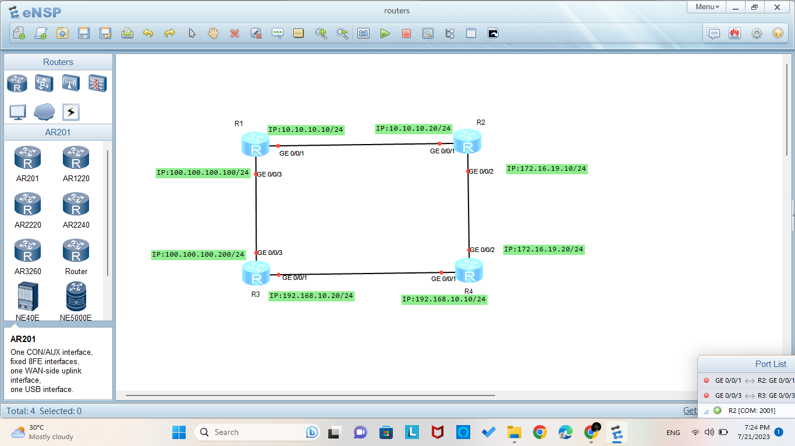

Lab 9

LSW1:

lacp priority 100

#

interface Eth-Trunk1

mode lacp-static

max active-linknumber 1

#

interface GigabitEthernet0/0/1

#

interface GigabitEthernet0/0/2

eth-trunk 1

lacp priority 100

#

interface GigabitEthernet0/0/3

eth-trunk 1

#

LSW2:

interface Eth-Trunk1

mode lacp-static

#

interface GigabitEthernet0/0/1

#

interface GigabitEthernet0/0/2

eth-trunk 1

#

interface GigabitEthernet0/0/3

eth-trunk 1

#

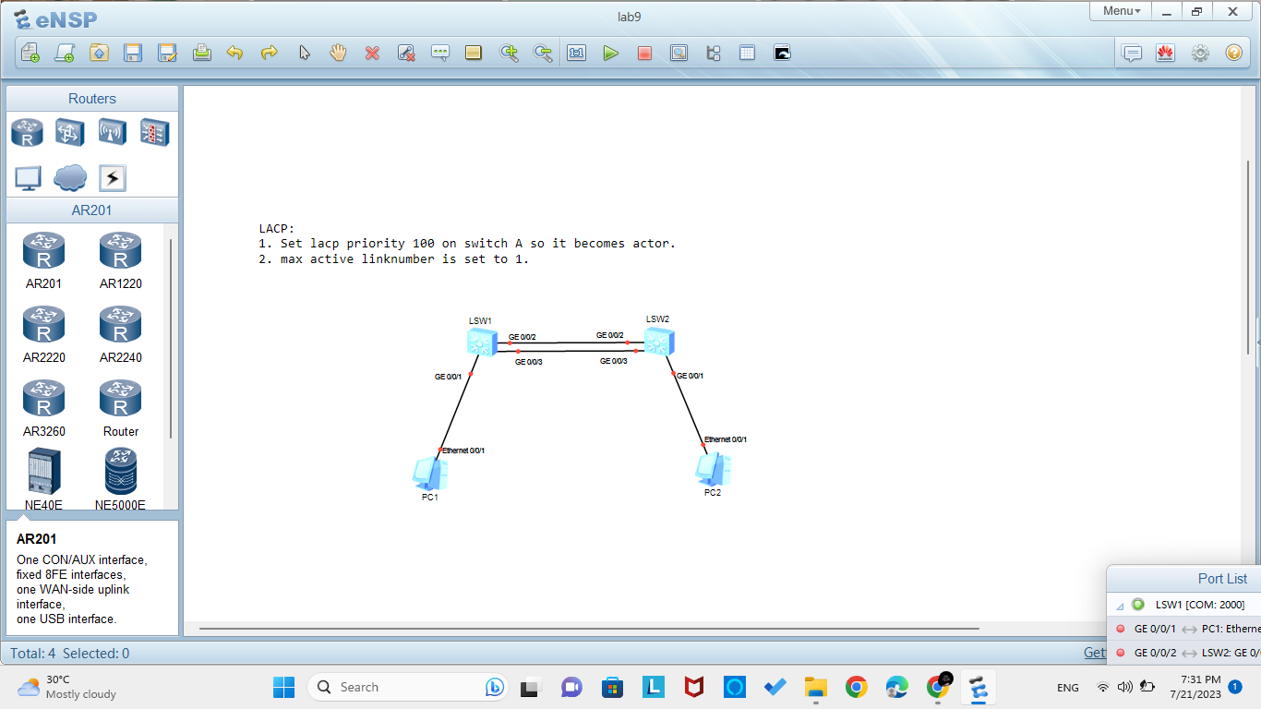

Lab 10

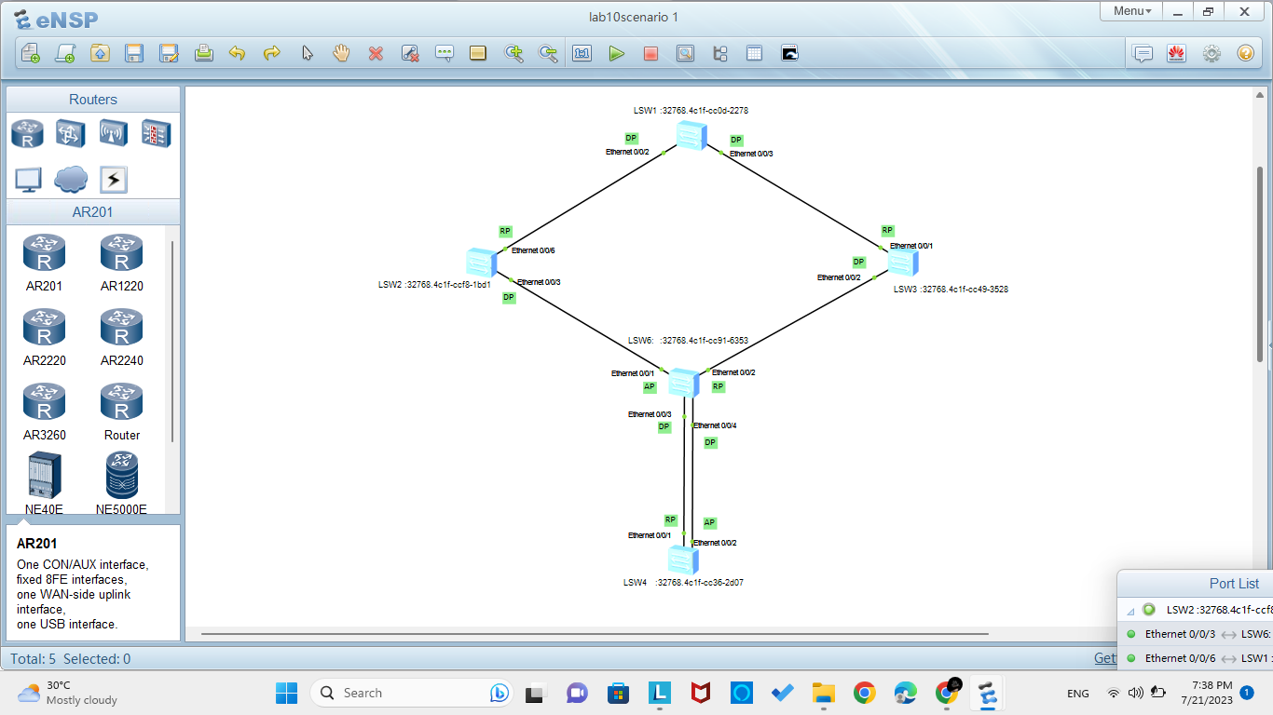

Lab 11

R1:

dhcp enable

#

ip pool 1

gateway-list 172.16.1.1

network 172.16.1.0 mask 255.255.255.0

dns-list 150.100.15.1 150.100.15.2

domain-name neduet.edu.pk

static-bind ip-address 172.16.1.33 mac-address 5489-9860-57

2B

#

ip pool 2

gateway-list 1.1.1.1

network 1.1.1.0 mask 255.255.255.0

dns-list 1.1.1.1

#

interface Ethernet0/0/0

ip address 150.100.12.1 255.255.255.0

dhcp select global

#

interface Ethernet0/0/1

ip address 1.1.1.1 255.255.255.0

dhcp select global

#

ip route-static 172.16.1.0 255.255.255.0 150.100.12.2

R2:

dhcp enable

#

interface Ethernet0/0/0

ip address 150.100.12.2 255.255.255.0

#

interface Ethernet0/0/1

ip address 172.16.1.1 255.255.255.0

dhcp select relay

dhcp relay server-ip 150.100.12.1

#

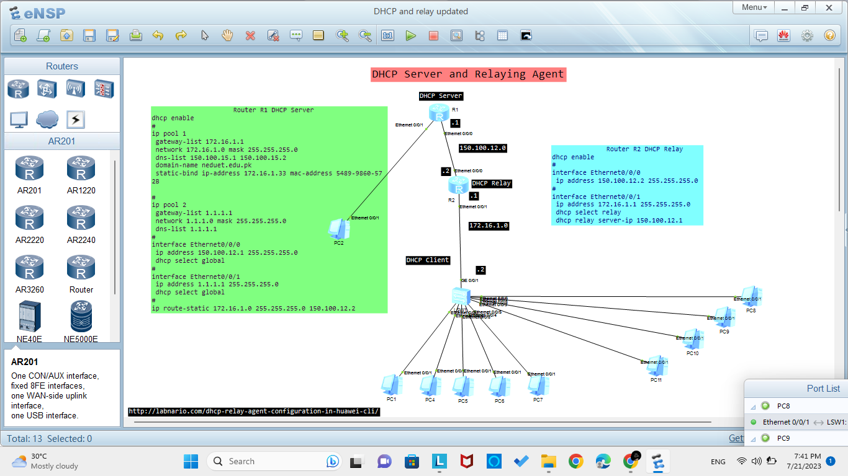

Lab 12

R1:

interface Ethernet0/0/1

ip address 80.80.80.1 255.255.255.0

#

interface GigabitEthernet0/0/0

ip address 10.10.10.1 255.255.255.0

#

interface GigabitEthernet0/0/1

ip address 20.20.20.1 255.255.255.0

#

rip 1

network 10.0.0.0

network 80.0.0.0

network 20.0.0.0

#

user-interface vty 0 4

user privilege level 15

set authentication password simple fatimar1

R2:

interface Ethernet0/0/0

ip address 70.70.70.2 255.255.255.0

#

interface Ethernet0/0/1

ip address 80.80.80.2 255.255.255.0

#

interface GigabitEthernet0/0/0

ip address 110.110.110.2 255.255.255.0

#

interface GigabitEthernet0/0/1

ip address 100.100.100.2 255.255.255.0

#

interface GigabitEthernet0/0/2

ip address 90.90.90.2 255.255.255.0

#

rip 1

network 90.0.0.0

network 100.0.0.0

network 110.0.0.0

network 80.0.0.0

network 70.0.0.0

#

user-interface vty 0 4

user privilege level 15

set authentication password simple fatimar2

R3:

interface Ethernet0/0/0

ip address 70.70.70.3 255.255.255.0

#

interface GigabitEthernet0/0/0

ip address 10.10.10.3 255.255.255.0

#

interface GigabitEthernet0/0/3

ip address 50.50.50.3 255.255.255.0

#

rip 1

network 10.0.0.0

network 50.0.0.0

network 70.0.0.0

#

user-interface vty 0 4

user privilege level 15

set authentication password simple fatimar3

R4:

interface Ethernet0/0/1

ip address 40.40.40.4 255.255.255.0

#

interface GigabitEthernet0/0/1

ip address 60.60.60.4 255.255.255.0

#

interface GigabitEthernet0/0/2

ip address 90.90.90.4 255.255.255.0

#

interface GigabitEthernet0/0/3

ip address 50.50.50.4 255.255.255.0

#

rip 1

network 60.0.0.0

network 40.0.0.0

network 50.0.0.0

network 90.0.0.0

#

user-interface vty 0 4

user privilege level 15

set authentication password simple fatimar4

R5:

interface Ethernet0/0/0

ip address 30.30.30.5 255.255.255.0

#

interface GigabitEthernet0/0/0

ip address 110.110.110.5 255.255.255.0

#

interface GigabitEthernet0/0/1

ip address 20.20.20.5 255.255.255.0

#

rip 1

network 30.0.0.0

network 110.0.0.0

network 20.0.0.0

#

user-interface vty 0 4

user privilege level 15

set authentication password simple fatimar5

R6:

interface Ethernet0/0/0

ip address 30.30.30.6 255.255.255.0

#

interface Ethernet0/0/1

ip address 40.40.40.6 255.255.255.0

#

interface GigabitEthernet0/0/1

ip address 100.100.100.6 255.255.255.0

rip 1

network 30.0.0.0

network 100.0.0.0

network 40.0.0.0

#

user-interface con 0

user-interface vty 0 4

user privilege level 15

set authentication password simple fatimar6

R7:

interface GigabitEthernet0/0/1

ip address 60.60.60.7 255.255.255.0

#

rip 1

network 60.0.0.0

#

Lab 13

R1:

interface Ethernet0/0/1

ip address 80.80.80.1 255.255.255.0

#

interface GigabitEthernet0/0/0

ip address 10.10.10.1 255.255.255.0

#

interface GigabitEthernet0/0/1

ip address 20.20.20.1 255.255.255.0

#

rip 1

network 10.0.0.0

network 80.0.0.0

network 20.0.0.0

#

user-interface vty 0 4

user privilege level 15

set authentication password simple fatimar1

R2:

interface Ethernet0/0/0

ip address 70.70.70.2 255.255.255.0

#

interface Ethernet0/0/1

ip address 80.80.80.2 255.255.255.0

#

interface GigabitEthernet0/0/0

ip address 110.110.110.2 255.255.255.0

#

interface GigabitEthernet0/0/1

ip address 100.100.100.2 255.255.255.0

#

interface GigabitEthernet0/0/2

ip address 90.90.90.2 255.255.255.0

#

rip 1

network 90.0.0.0

network 100.0.0.0

network 110.0.0.0

network 80.0.0.0

network 70.0.0.0

#

user-interface vty 0 4

user privilege level 15

set authentication password simple fatimar2

R3:

interface Ethernet0/0/0

ip address 70.70.70.3 255.255.255.0

#

interface GigabitEthernet0/0/0

ip address 10.10.10.3 255.255.255.0

#

interface GigabitEthernet0/0/3

ip address 50.50.50.3 255.255.255.0

#

rip 1

network 10.0.0.0

network 50.0.0.0

network 70.0.0.0

#

user-interface vty 0 4

user privilege level 15

set authentication password simple fatimar3

R4:

interface Ethernet0/0/1

ip address 40.40.40.4 255.255.255.0

#

interface GigabitEthernet0/0/1

ip address 60.60.60.4 255.255.255.0

#

interface GigabitEthernet0/0/2

ip address 90.90.90.4 255.255.255.0

#

interface GigabitEthernet0/0/3

ip address 50.50.50.4 255.255.255.0

#

rip 1

network 60.0.0.0

network 40.0.0.0

network 50.0.0.0

network 90.0.0.0

#

user-interface vty 0 4

user privilege level 15

set authentication password simple fatimar4

R5:

interface Ethernet0/0/0

ip address 30.30.30.5 255.255.255.0

#

interface GigabitEthernet0/0/0

ip address 110.110.110.5 255.255.255.0

#

interface GigabitEthernet0/0/1

ip address 20.20.20.5 255.255.255.0

#

rip 1

network 30.0.0.0

network 110.0.0.0

network 20.0.0.0

#

user-interface vty 0 4

user privilege level 15

set authentication password simple fatimar5

R6:

interface Ethernet0/0/0

ip address 30.30.30.6 255.255.255.0

#

interface Ethernet0/0/1

ip address 40.40.40.6 255.255.255.0

#

interface GigabitEthernet0/0/1

ip address 100.100.100.6 255.255.255.0

rip 1

network 30.0.0.0

network 100.0.0.0

network 40.0.0.0

#

user-interface con 0

user-interface vty 0 4

user privilege level 15

set authentication password simple fatimar6

R7:

interface GigabitEthernet0/0/1

ip address 60.60.60.7 255.255.255.0

#

rip 1

network 60.0.0.0

#

Lab 12 & 13 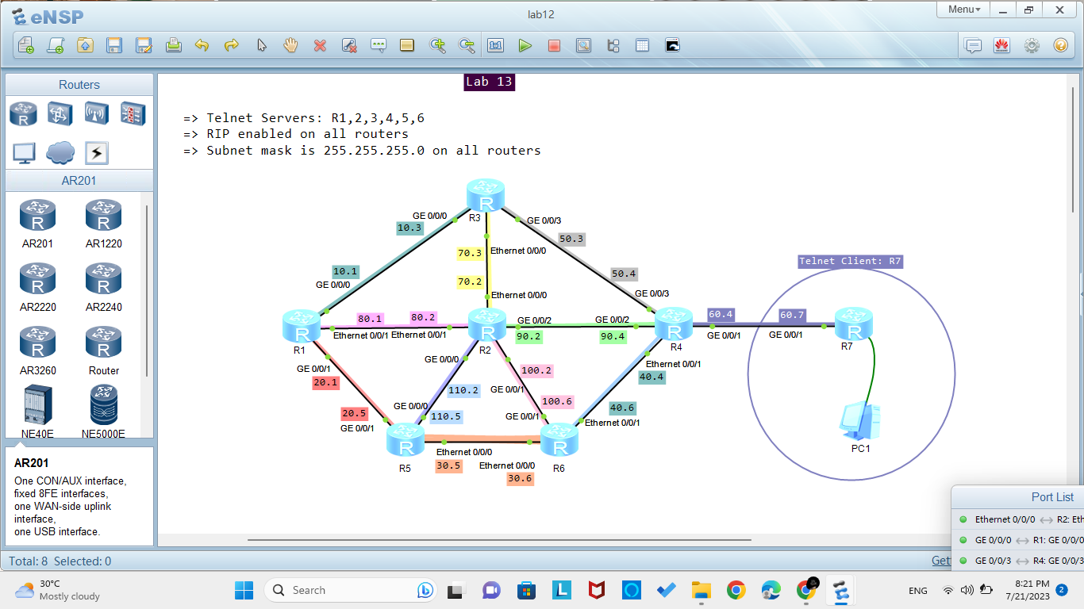

Lab 14

R1:

interface Ethernet0/0/0

ip address 12.1.1.1 255.255.255.0

#

interface Ethernet0/0/1

ip address 13.1.1.1 255.255.255.0

#

interface LoopBack1

ip address 1.1.1.1 255.255.255.255

#

ospf 1

area 0.0.0.0

authentication-mode md5 1 cipher Tp,R+2.p*4jKUGU-KkpB'EH#

network 1.1.1.1 0.0.0.0

network 12.1.1.0 0.0.0.255

area 0.0.0.1

network 13.1.1.0 0.0.0.255

#

R2:

interface Ethernet0/0/0

ip address 12.1.1.2 255.255.255.0

#

interface Ethernet0/0/1

ip address 24.1.1.2 255.255.255.0

#

interface LoopBack2

ip address 2.2.2.2 255.255.255.255

#

ospf 1

area 0.0.0.0

authentication-mode md5 1 cipher Sx^OF8POI2pe}@HMNPn@OFa#

network 2.2.2.2 0.0.0.0

network 12.1.1.0 0.0.0.255

area 0.0.0.2

network 24.1.1.0 0.0.0.255

vlink-peer 4.4.4.4

#

R3:

interface Ethernet0/0/0

ip address 13.1.1.3 255.255.255.0

#

interface Ethernet0/0/1

ip address 192.168.1.1 255.255.255.0

#

interface LoopBack3

ip address 3.3.3.3 255.255.255.255

#

ospf 1

import-route rip 1

area 0.0.0.1

network 3.3.3.3 0.0.0.0

network 13.1.1.0 0.0.0.255

#

rip 1

version 2

network 192.168.1.0

import-route ospf 1

#

R4:

interface Ethernet0/0/0

ip address 24.1.1.4 255.255.255.0

#

interface Ethernet0/0/1

ip address 45.1.1.4 255.255.255.0

#

interface GigabitEthernet0/0/0

ip address 6.6.6.7 255.255.255.0

#

interface LoopBack4

ip address 4.4.4.4 255.255.255.255

#

ospf 1

import-route rip 1

area 0.0.0.0

authentication-mode md5 1 cipher _.^sWI}o-G3IF$':[285/OX#

area 0.0.0.2

network 4.4.4.4 0.0.0.0

network 24.1.1.0 0.0.0.255

vlink-peer 2.2.2.2

area 0.0.0.3

network 6.6.6.0 0.0.0.255

vlink-peer 66.66.66.66

#

rip 1

version 2

network 45.0.0.0

import-route ospf 1

#

R5:

interface Ethernet0/0/0

ip address 45.1.1.5 255.255.255.0

#

interface GigabitEthernet0/0/0

ip address 6.6.6.7 255.255.255.0

#

interface LoopBack5

ip address 5.5.5.5 255.255.255.0

#

rip 1

version 2

network 45.0.0.0

network 5.0.0.0

#

R6:

interface Ethernet0/0/0

ip address 6.6.6.6 255.255.255.0

#

interface Ethernet0/0/1

ip address 77.77.77.6 255.255.255.0

#

interface LoopBack6

ip address 66.66.66.66 255.255.255.0

#

ospf 1

area 0.0.0.0

authentication-mode md5 1 cipher JNI>1sgdH+@X,k6.E\Z,@O(#

area 0.0.0.3

network 6.6.6.0 0.0.0.255

network 66.66.66.66 0.0.0.0

vlink-peer 4.4.4.4

area 0.0.0.7

network 77.77.77.0 0.0.0.255

#

R7:

interface Ethernet0/0/0

ip address 77.77.77.7 255.255.255.0

#

interface LoopBack7

ip address 7.7.7.7 255.255.255.0

#

ospf 1

area 0.0.0.7

network 7.7.7.7 0.0.0.0

network 77.77.77.0 0.0.0.255

#

